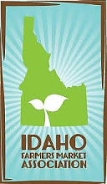
SNAP AND DOUBLE UP FOOD BUCKS
OUTREACH MATERIALS ORDER FORM
Materials are available free of charge to SNAP-Friendly IFMA Members

Market Name: _______________________________________________________________
Your Name: __________________________ Your email: _______________________
Your Mailing Address:_________________________________________________________
__________________________________________________________________________
Item | Description |  | Quantity Requested
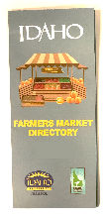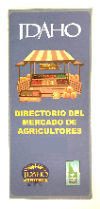 | Current Year Idaho Farmers Market Directory Brochure – English or Spanish Language |  | English Brochures:  ____________  Spanish Brochures:  ____________
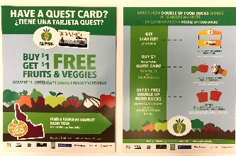 | Glossy 8.5” x 11” Double Sided Flyer in English and Spanish promoting SNAP and DUFB at Idaho Farmers Markets
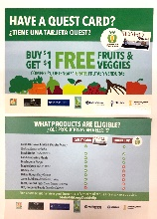 | Glossy, full color double sided Postcard in English and Spanish promoting SNAP and DUFB at Idaho Farmers Markets
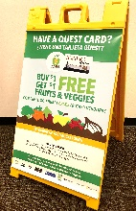 | Heavy Duty Resin Sandwich Board and Two Full Size, Full Color Posters in English and Spanish promoting SNAP and DUFB at Idaho Farmers Markets |  | Sandwich Board and 2 Posters  Sandwich Board only  Posters only
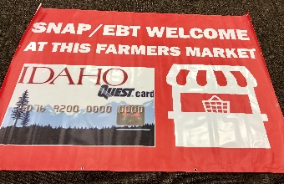 |  | Large vinyl outdoor banner advertising SNAP

Please submit your order by email to info@idahofma.org or mail to Idaho Farmers Market Association,
PO Box 6992, Boise, ID 83707.

